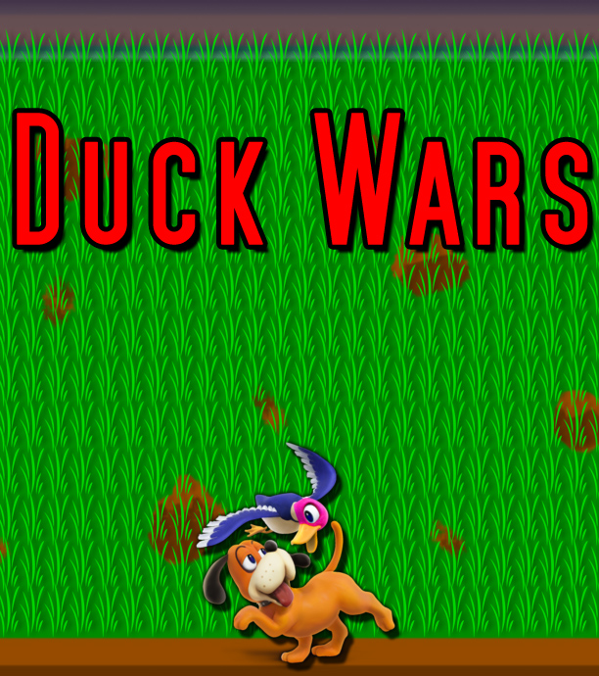

­­

by Elaine Allison Schultz

**Table of Contents**

|  |  |
| --- | --- |
|  |  |
| Table of Contents……………………………………………………………………….. | 2 |
| Introduction……………………………………………………………………………... | 2 |
| Keyboard Controls……………………………………………………………………… | 2 |
| Description………………………………………………………………………………. | 3 |
| Step by Step Process……………………………………………………………………. | 3 |
| List of Classes…………………………………………………………………………… | 4 |
| Character Designs………………………………………………………………………. | 4 |
| Background Design…………………………………………………………………….. | 6 |
| Project Schedule………………………………………………………………………… | 6 |
| Vision…………………………………………………………………………………….. | 7 |
| Road Map………………………………………………………………………………... | 7 |
| Sprint Backlog…………………………………………………………………………… | 8 |
| Flowcharts…………………………………………………………………………... | 9 |
| System Design…………………………………………………………………………... | 12 |
| Program Development…………………………………………………………………. | 13 |
| Testing…………………………………………………………………………………… | 13 |
|  |  |

**Introduction**

You are man’s best friend. The ducks have claimed war upon humanity! No longer will they tolerate duck season! This is no time to laugh at your master like the good old days when he had his twelve gauge shot gun. Now ducks are hunting. And they are hunting you pooch. It is time to seek for redemption and save humanity e.g. your master!

Be quick! Be tactical because you never know when duck-poo may be flying at your face and if your mouth is open … need I say more? It is harmful to your health, especially your paws. Also do not allow them get past you or they will begin destroying your master’s property first. Lastly, believe in your bark it is far worse than your bite and God speed pup!

**Keyboard Controls**

|  |  |
| --- | --- |
| Press W or the Up Arrow | Moves the dog UP. |
| Press D or the Right Arrow | Moves the dog RIGHT. |
| Press S or the Down Arrow | Moves the dog DOWN. |
| Press A or the Left Arrow | Moves the dog LEFT. |

**Description**

Duck Wars is a two-dimensional game that requires collusion and dodging. The player controls man’s best friend, the dog, and bites those ducks who claimed war among humanity because of Duck Season. The player’s arsenal is biting. There is a wave of ducks per level; however, the ducks are able to fire back with their own poo. The ducks begin from emerging out of their pond, at the top of the screen. Do not allow them get to the ground; if they are successful of taking down man’s loyal companion first then its game over.

The goal of the player is to defeat all the ducks without dying or to prevent the ducks reaching the ground. The player earns points by colliding with the duck. The maximum points a life a player can have is five hundred. It’s possible that the player may recover some health from a dog bone; however, a steak can trigger the dog’s bark which causes a wave to halt all ducks and their duck doo-doo.

**Step by Step Process to Create Duck Wars**

1. First is to create the window of the game.

2. The background must have a marsh environment.

3. Must populate one dog who is controlled by the player.

4. The dog must be able to move up and down and left to right.

5. The player’s controller is the keyboard.

6. Must populate a duck and then more than one.

7. The duck automatically moves down.

8. The Duck must be able to fire a duck doo-doo.

9. The Dog player must be able to collide to a duck.

10. If the duck is hit by the dog than the duck is removed.

11. If the dog is hit by a duck doo-doo then the game is over.

12. If the dog doesn’t prevent a duck going pass the dirt then the game is over.

13. If the dog runs out of health then the game is over.

14. If a certain amount of ducks are gone then the level is passed.

**List of Classes**

• DuckWarsGame [The Main Controller]

• Play [Inner Class in Main Controller]

• Title [The second class]

• Blinker [Inner Class in Title]

• Sound [The third class]

**Character Designs**

The duck and dog is related to NES theme called Duck Hunt. There is no Zap Gun as you are not the hunter, but instead the role if you choose to accept is the beloved dog; the dog is required to bite a duck while the duck is able throw their doo-doo at player aka “the dog. The duck, dog, duck doo-doo, the dog and duck being hit were created using Photoshop. References were used by the video game called “Duck Hunt” with some alternations. Some images also came from Super Smash Bros. 4.

**Image References:**

|  |
| --- |
|  |
| “Duck Hunt” images of the dog and ducks. |

|  |  |
| --- | --- |
| The dog’s movement, cleared a level or resets his position. |  |
| The dog being hit. |  |
| When the ducks defeat the dog than its game over. |  |
| When the ducks get passed the dog than its game over. |  |
| When the dog wins. | *Original image belongs to Super Smash Bros. 4.* |
| Alternated or used images for the dog player. | |

|  |  |
| --- | --- |
| The dog’s movement, cleared a level or resets his position. |  |
| The dog being hit. |  |
| When the ducks defeat the dog than its game over. |  |
| When the duck wins for defeating the dog or getting passed him. | *Original image belongs to Super Smash Bros. 4.* |
| Alternated or used images for the duck. | |

**Background Design**

The background design correlates with a marsh environment, including a pond at the very top. The environment will be adjusted with more grass and mud. The custom design of the background was created by using Photoshop.

|  |  |
| --- | --- |
|  |  |
| Duck Hunt’s background for reference. | Alternated image of the background. |

**Project Schedule**



**Vision**

Duck Wars is design to be a witty game while at the same time reliving an old classic pushed to the next level. The ducks have claimed war upon humanity, but man’s best friend the ever beloved dog; who would laugh at his master’s mistakes now seeks redemption for his beloved owner and at the same time save humanity. The game is to entertain for all ages and my very interested client, Mr. Steve Harper.

**Road Map**

• Setup GIT

• Create duck

• Create dog

• Create duck doo-doo

• Create the background environment

• Create Duck Wars’ Controller

• Create timer events

• Create user interaction

• Collusion Detection

• Count loses

• Count health remaining

**Product Backlog**

• Set up GIT for Backup the project, MEDIUM

• Create a duck, MEDIUM

• Create a dog, MEDIUM

• Create background, MEDIUM

• Create duck doo-doo, SMALL

• Create a Controller Class, MEDIUM

• Draw the dog on the screen, SMALL

• Draw the duck on the screen, MEDIUM

• Move the duck, MEDIUM

• Create keyboard function for dog to move, MEDIUM

• Create win or lose, SMALL

• Duck throws a doo-doo, SMALL

• Detect a hit for duck and dog, SMALL

• Test if the duck and dog moves, SMALL

• Test if the duck and dog moves, SMALL

• Test dog for collision detection with keyboard, LARGE

**Sprint Backlog**

• Revised the code for easier intersection detections with the JLabel that use images. I added additional images and made some adjustments for the game to be more difficult. There are two ways to lose which are running out of health or the duck getting passed the dog. Resizing the original images was also required. Added in more if statements and methods to track and trigger wins and losses. No longer used the MouseMotionListener and switched to the KeyListener which the controls are very basic.

**Flowcharts**

|  |
| --- |
| **Start** |
|  |

|  |
| --- |
| **Timer** |
|  |

|  |
| --- |
| **Keyboard** |
|  |

**System Design**

|  |
| --- |
| **UML Class Diagram** |
|  |

**Program Development**

This is an example which makes the game more related to the old classics.

* Blinking Text from Title.

|  |
| --- |
|  |
| The press spacebar text is visible. |

|  |
| --- |
|  |
| The press spacebar text is no longer visible. |

**Testing**

Once the planning and images were finished, code was tested one step at a time. An understanding of the process was creating the controller class with only the JFrame being visible with the background image. Following the duck and the dog and making them move. Once the functions were created, some alternations of the code were required until the bugs were cleared up or when the game was playable. Not everything was bug free, but the main concept and its mechanics were achieved.